Senior Project CIS 4911-U01

Multi-Touch and Mid-Air Framework

Visualizer

User Manual

Team Members:

Richard  A. Lopez

January 28 2014

Mentor:

Francisco Ortega

Professor:

Masoud Sadjadi

Overview

Input devices have advanced at an outstanding rate in the last few decades. The introduction of the mouse was one of the factors that brought the personal computer out of the technical user niche and into the regular consumer. Now touch input is in almost every cellphone and readily available to the general public. Newer input forms have been developed since such as multi touch screen, 3D mouse, midair tracking, and others. Up until now developers have had to code their respective games and applications for the individual input devices which make it a time consuming task and it limits the utilization of more than one input device in use at a time.

The Touch Air Motion Framework is trying to create a more encompassing input device library such that developers can simply choose their input devices and code their apps without having to deal with the individuality of each device. This document pertains to the visualization interface for the TAM framework.

MANUAL

Requirements

To utilize version 1.0 of the TAM framework you need the following:

* Touch screen computer
* Windows 8 or greater
* 2 GB RAM minimum
* 512 MB video card minimum
* Microsoft Visual Studio 2013
* Qt version 5.4
* Qt plugin for Visual Studio 2013 version 5.4

Installation

For instructions on the installation of the TAM framework please refer to the “Installation” manual located in the Code folder for this version.

Features

* **Drawing:** With any multi touch screen running Windows 8 or greater simply place your fingers in the drawing area, immediately the places where your finger(s) are touching the screen will be colored. The system can handle up to 10 fingers at any one time. Move your fingers around and you can see how your movements are traced in the drawing area.

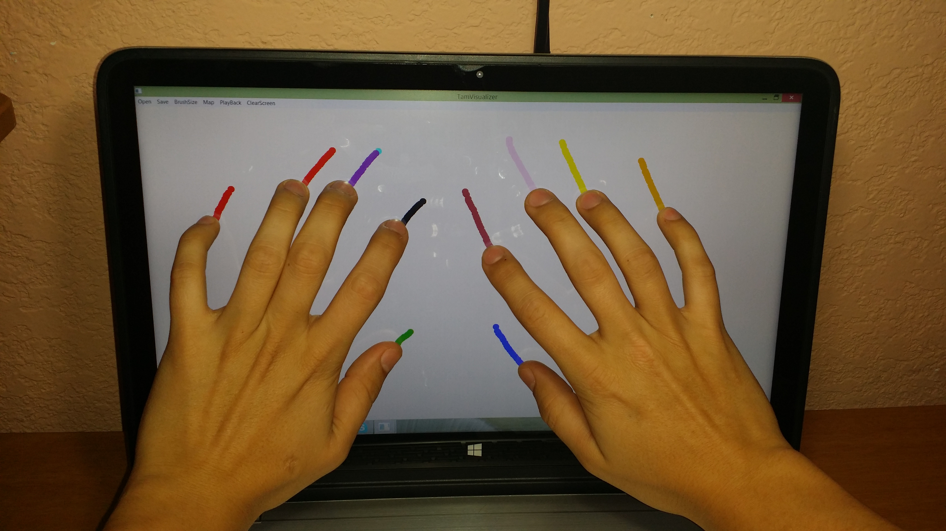

* **Mapping:** Select any of the mapping functions provide for you in the order they are label they do the following: Map 1 is the default mapping the exact place that your fingers are touching in the screen. Map 2 is a mapping of twice the location of your fingers on the screen. Map 3 is a mapping to ½ the location of your fingers on the screen.

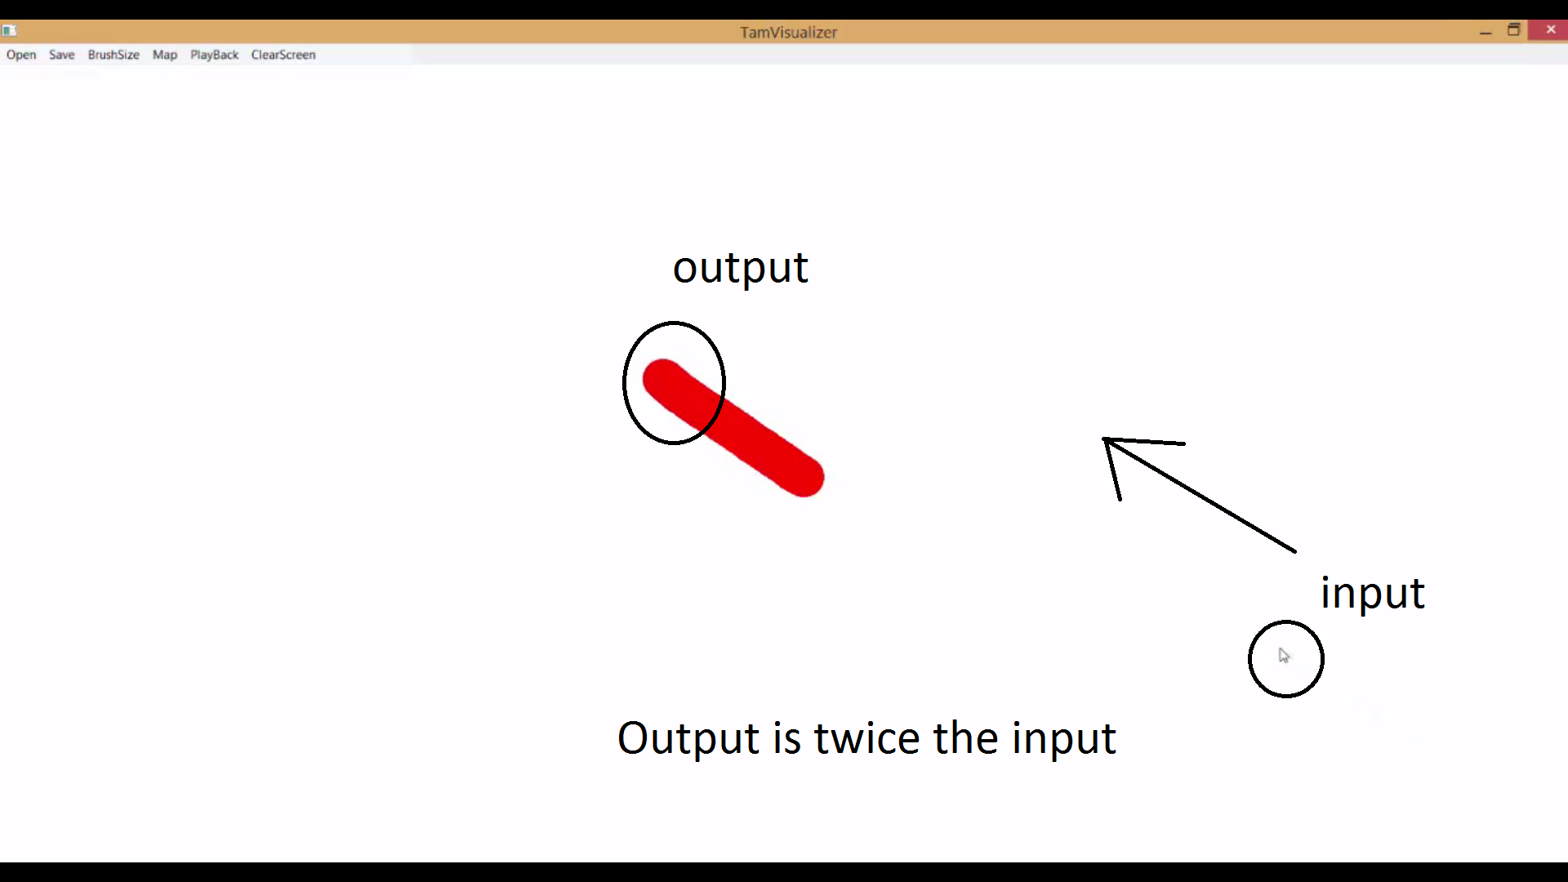

* **Input Recording:** As you touch the screen and draw through it, all of the individual touch points are being saved to a list. This is a temporary file maintained only as long as the application is running or you choose to replay your motions.
* **PlayBack:** To replay your drawing all you need to do is press the “Replay” button, this will start a replay of all your past touch events. At the end the list containing all these saved points is cleared to allow you to create new touch points.

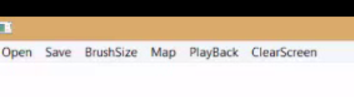

* **Save Touch Points:** If you need a more permanent list of all your touch points, simply press the “Save” button after you finished drawing. This will prompt you with a save box, search the location you what the file to be saved to and type the name you prefer for the file, finally press “Save” and your data will be saved permanently.

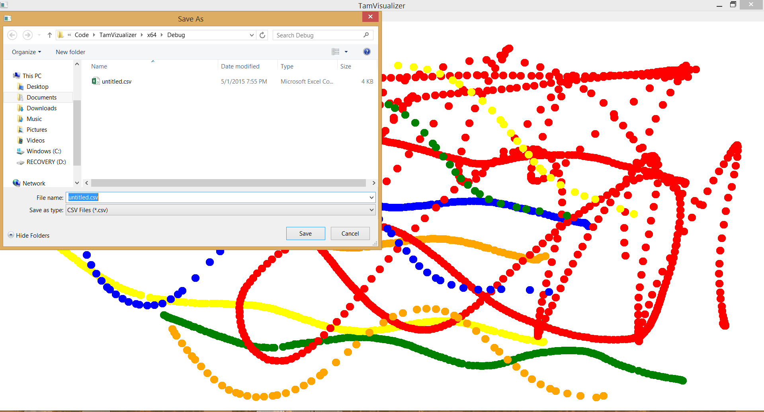

* **PlayBack from a File:** There is no use to having your data in a file if you can’t see the 2D representation. Simply press the “Open” button, an open box will prompt you to search for the location of the file, once you find it all you must do is double click on the file or single click and press “Open”. A replay of your drawing will start immediately.

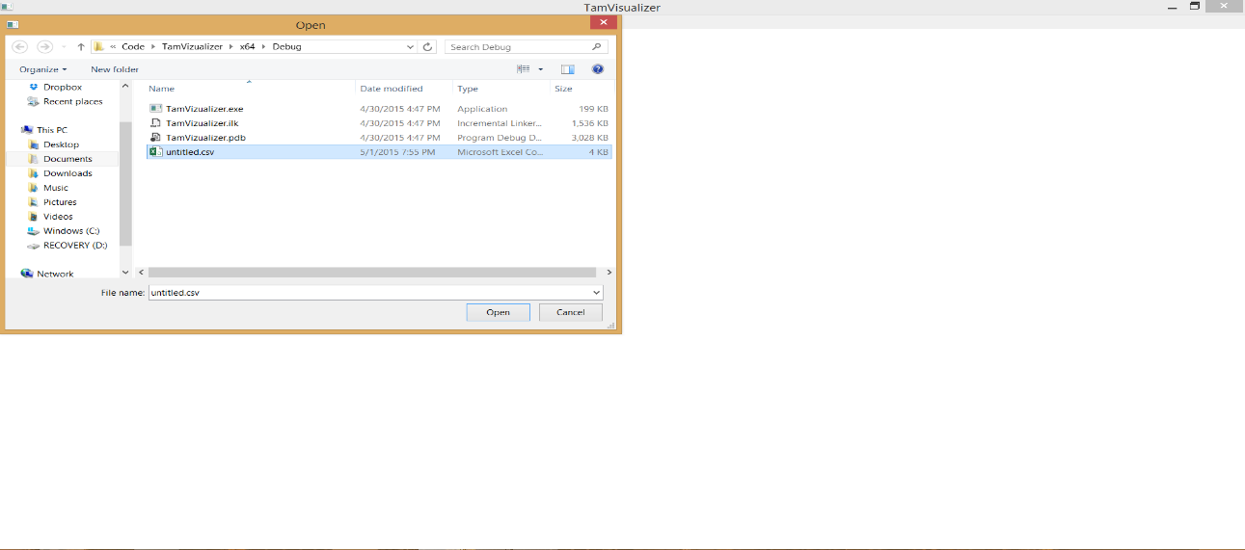

* **Resize Brush:** Want to change the size of the drawing brush? All you need to do is click the “BrushSize” button; this will open the menu of all available brush sizes, select one and start drawing with your new brush size.

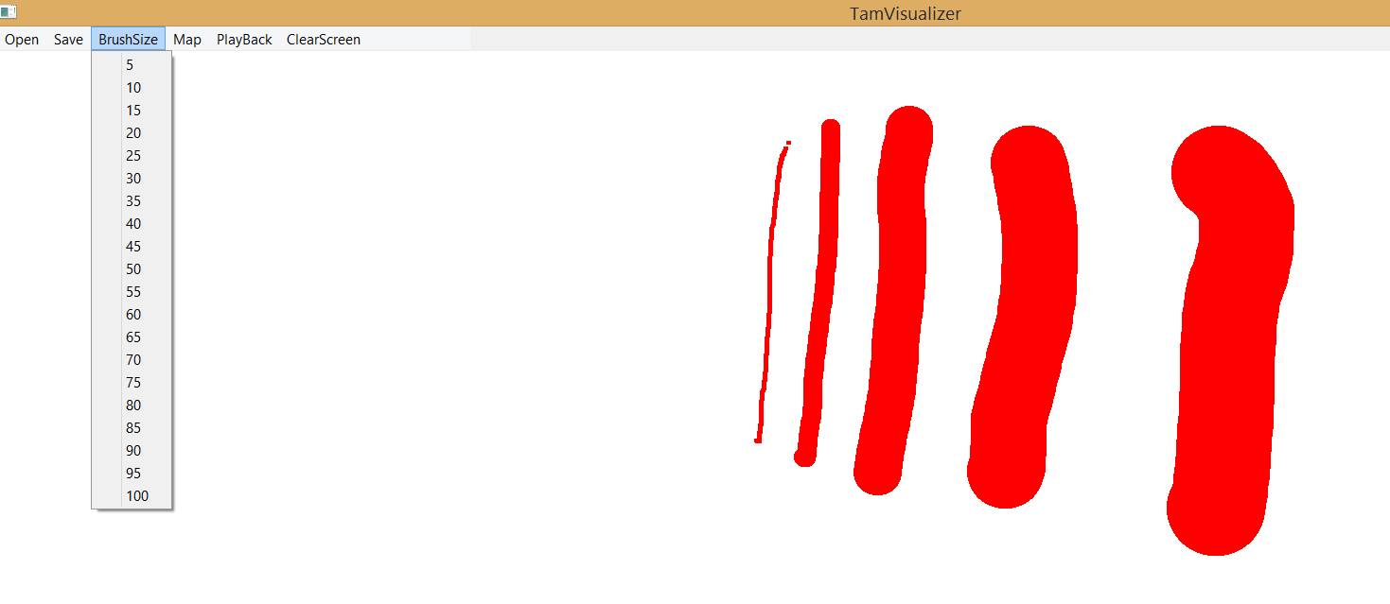

* **Clear:** If the screen is getting too cluttered with drawings simply click on the “ClearScreen” button, this will clear your screen completely without deleting the list of touch points you have created previously.

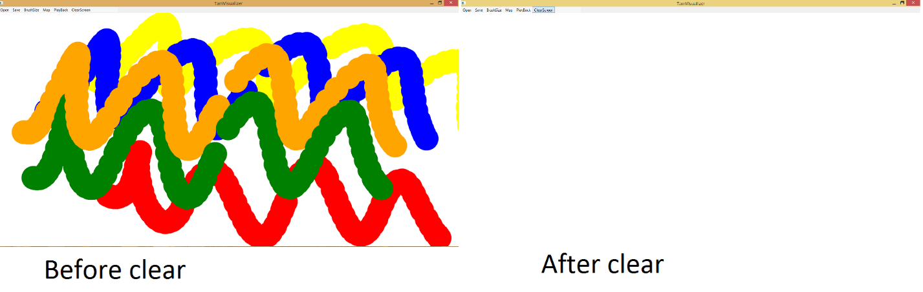

* **Debug:** If you need to know the specific points on the screen, the id of the fingers, the time of the action, or any other output that the application creates all you need to do is look at the Debug Monitor, this is the screen that opens along with the Draw Area screen. This will receive any output sent by the system to the Standard output.

